1.)Zig zag pattern in an array.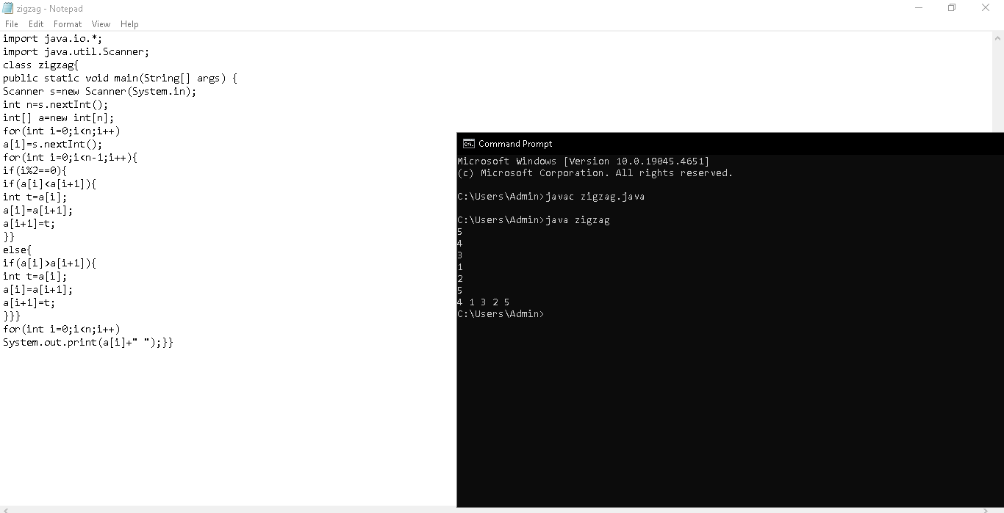

2.)Find the peak element from the array.

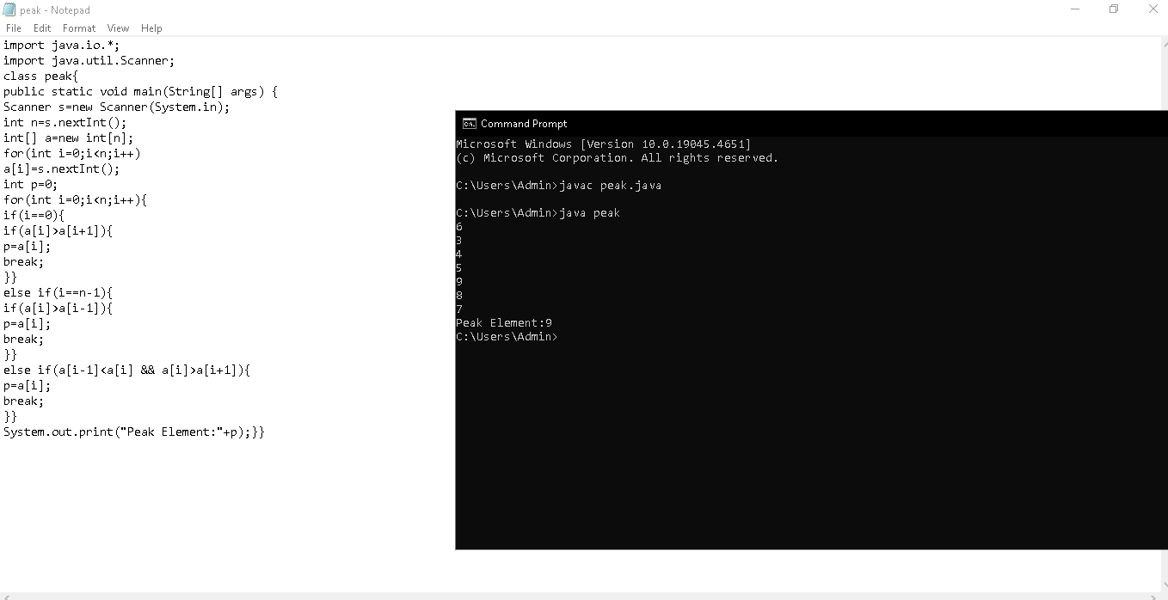

3.)Find The maximum subarray(contiguous).

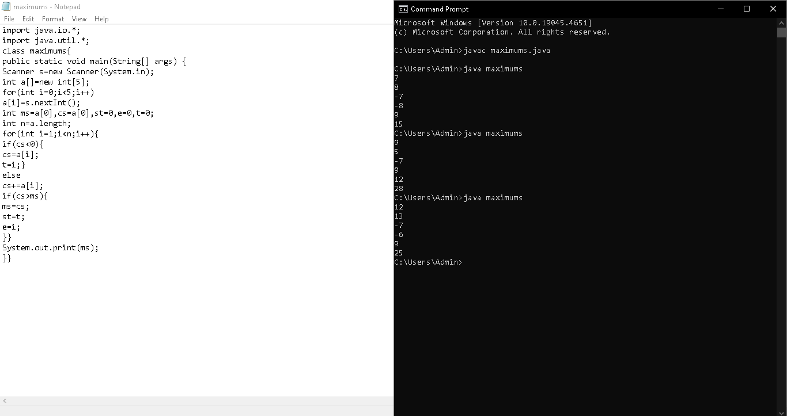

4.)Length of Last word.

